# Cadence Sensor Summary

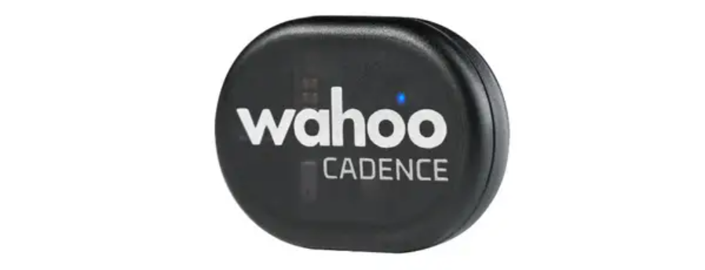

Figure – Image of RPM Cycling Cadence Sensor (Wahoo Fitness n.d.)

## Introduction

The Smart Bike project uses a Wahoo Cadence Sensor to capture cadence data. This document will summarize how the relevant code operates, some examples of the payload and how the sensor fits into the architecture of the Smart Bike as a whole.

More information on the sensor can be found through the following link: <https://au.wahoofitness.com/devices/bike-sensors/speed-and-cadence-sensors-bundle>

## Code

This sensor requires two scripts to operate which include ‘mqtt_client.py’ and ‘cadence_sensor.py’. The ‘mqtt_client.py’ script is a MQTT client that enables publishing to and subscribing from MQTT topics in HiveMQ cloud and, in this instance, is used for cadence data. This script ultimately provides many of the functionalities needed to connect with the necessary components such as the HiveMQ MQTT Broker and establishing a connection to a Raspberry Pi device. The ‘cadence_sensor.py’ script uses the functionalities of the ‘mqtt_client.py’ script to set up a number of different connections and also to publish data from the sensor to the MQTT broker. Some of the things that this script does includes establishing a connection with the cadence sensor and setting up the HiveMQ connection. It will connect to multiple cadence sensors if there are more than one Smart Bike. The folder also contains a script called ‘subsciber.py’ which basically subscribes to the cadence topic and prints everything it receives.

## Example Payloads

Below is a table showcasing examples of the payload that would be published to the MQTT broker. Cadence indicates how fast the pedals of the bike move and is measured in revolutions per minute and has a range of 0 to 200.

|  |  |  |
| --- | --- | --- |
| **Topic** | **Payload** | **Description** |
| bike/00001/cadence | {“ts”: 11662625808, “value”: 173} | The pedals of Bike One are rotating at 173 revolutions per minute |
| bike/00002/cadence | {“ts”: 11662625808, “value”: 89} | The pedals of Bike Two are rotating at 89 revolutions per minute |
| bike/00002/cadence | {“ts”: 11662625808, “value”: 27} | The pedals of Bike Two are rotating at 27 revolutions per minute |

## Architecture

How the Wahoo Cadence Sensor fits into the architecture of the Smart Bike as a whole is showcased in figure 2 below. As you can see, the cadence sensor (which can be identified as the Wahoo Speed and Cadence Sensor) communicates with a Raspberry Pi device and makes its way to the HiveMQ MQTT Broker and eventually ends up in the MongoDB database. The stored data is then able to be used by the end user systems such as the mobile application and Unity software.

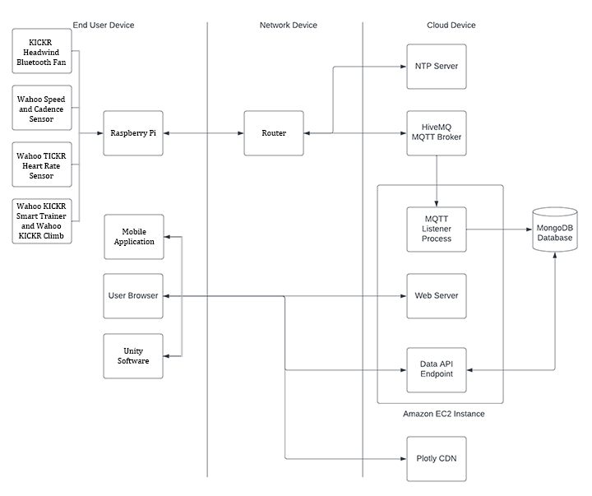

Figure - Suitable Architecture based on the architecture provided by Adrian Grigo and modified by myself

## References

Wahoo Fitness (n.d.) Image of RPM Cycling Cadence Sensor, Wahoo Fitness, accessed 25 September 2022. <https://au.wahoofitness.com/devices/bike-sensors/wahoo-rpm-cadence-sensor>